1. A Factor-Based Approach to Asset Management

[Factor Investing]

Assets earn high returns (risk premiums) to compensate investors for the losses they incur during bad times (i.e., because they are exposed to underlying factor risks).

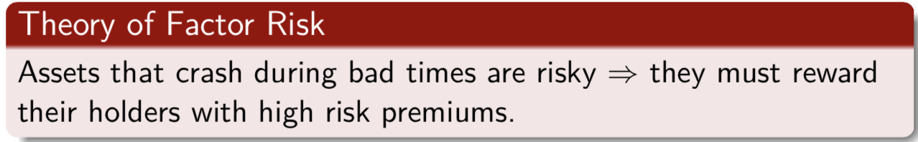

Each factor defines a different set of *bad times*, for example

* Bad economic times (e.g., periods of high inflation and low economic growth)
* Bad times for investments (e.g., periods when aggregate market or certain investment strategies perform badly)

Investors exposed to losses during bad times are compensated by risk premiums in good times.

**Factors matter, not assets**:

Investing right requires looking through asset class labels to understand the factor content.

**Assets are bundles of factors**:

Equities and government bonds can be considered factors themselves; corporate bonds, hedge funds and private equity contain different amounts of equity risk, volatility risk, interest rate risk, and default risk.

**Different investors need different risk factors**:

Each investor has different preferences, or risk aversion coefficients, for each different source of factor risk.

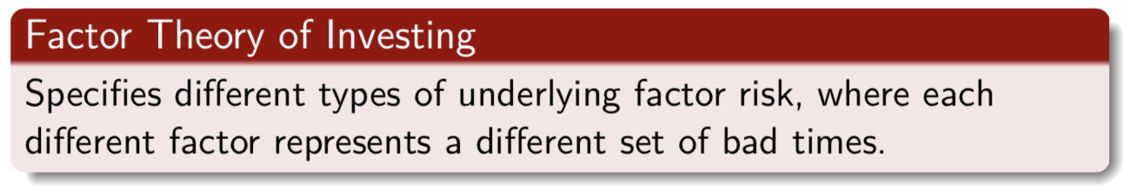

Example [Simplest Factor Model: CAPM]

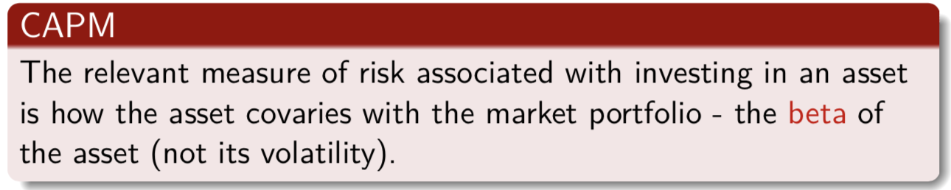

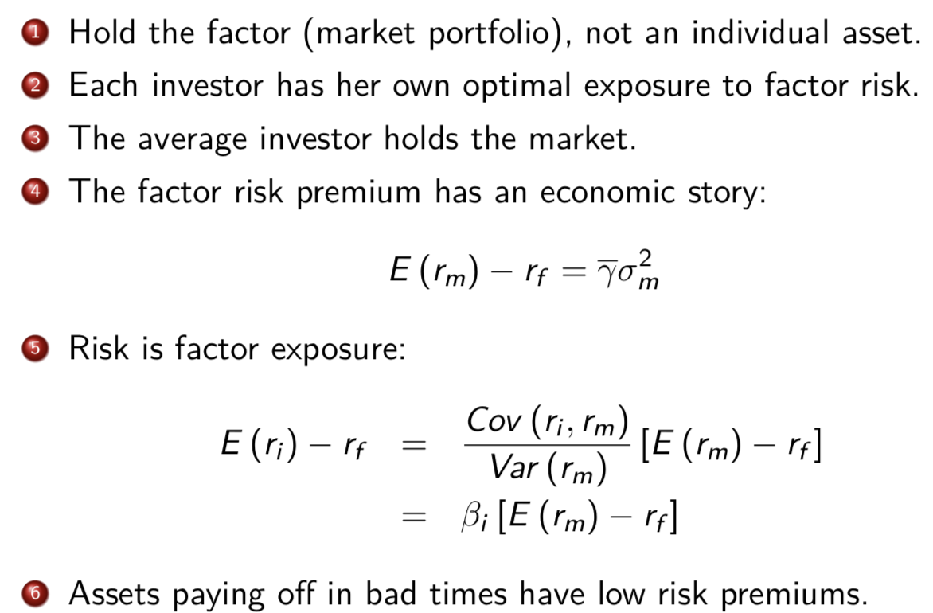

low beta

price of risk (average market risk aversion) * quantity of risk

Why market earns a risk premium

2. Active Management

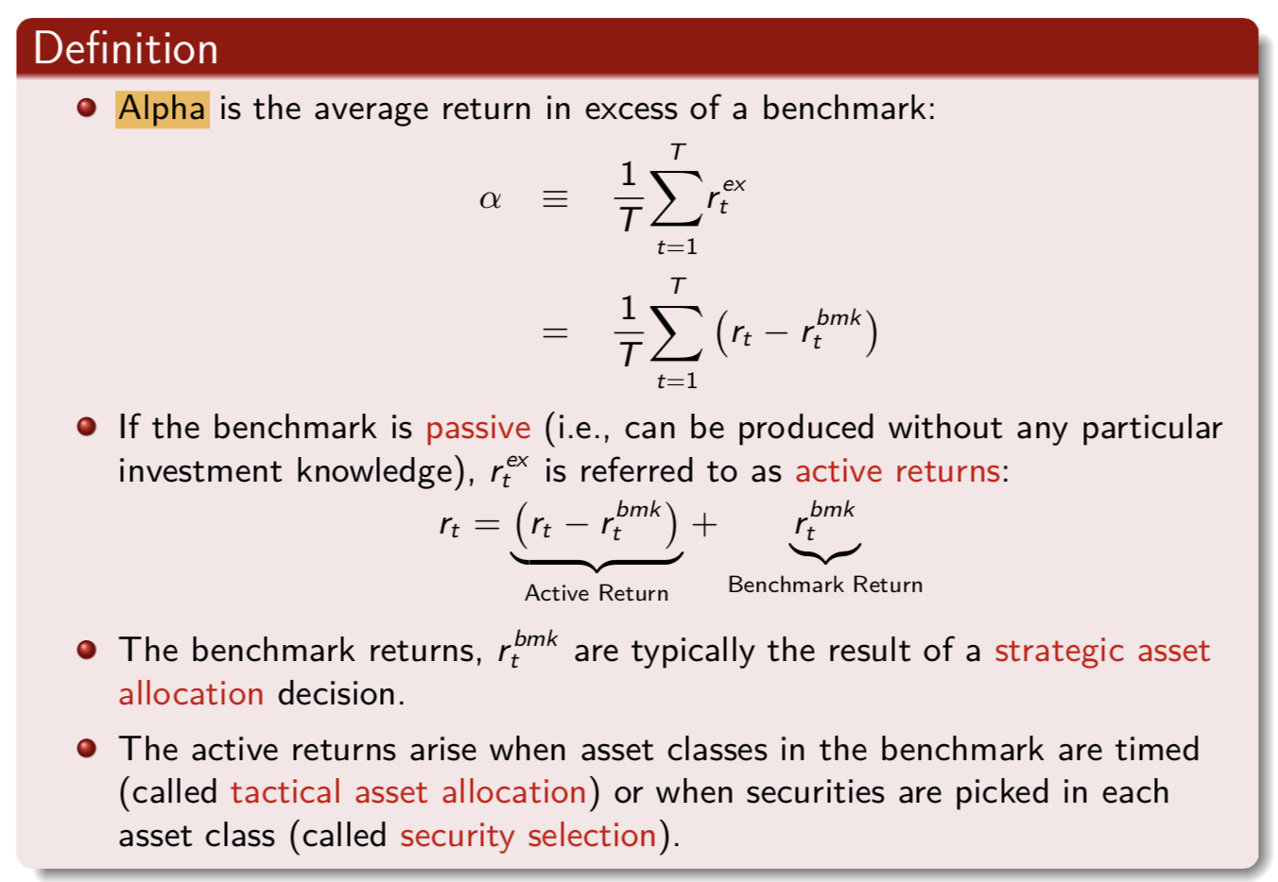

[Fund 1]

40% equities + 60% bonds

rtbmk = 0.4 rS&P + 0.6 rbond

[Fund 2]

10% equities + 90% bonds

rtbmk = 0.1 rS&P + 0.9 rbond

Shortcoming: Dependent on benchmark

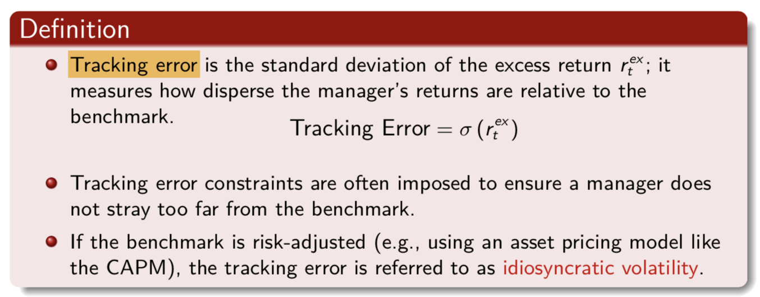

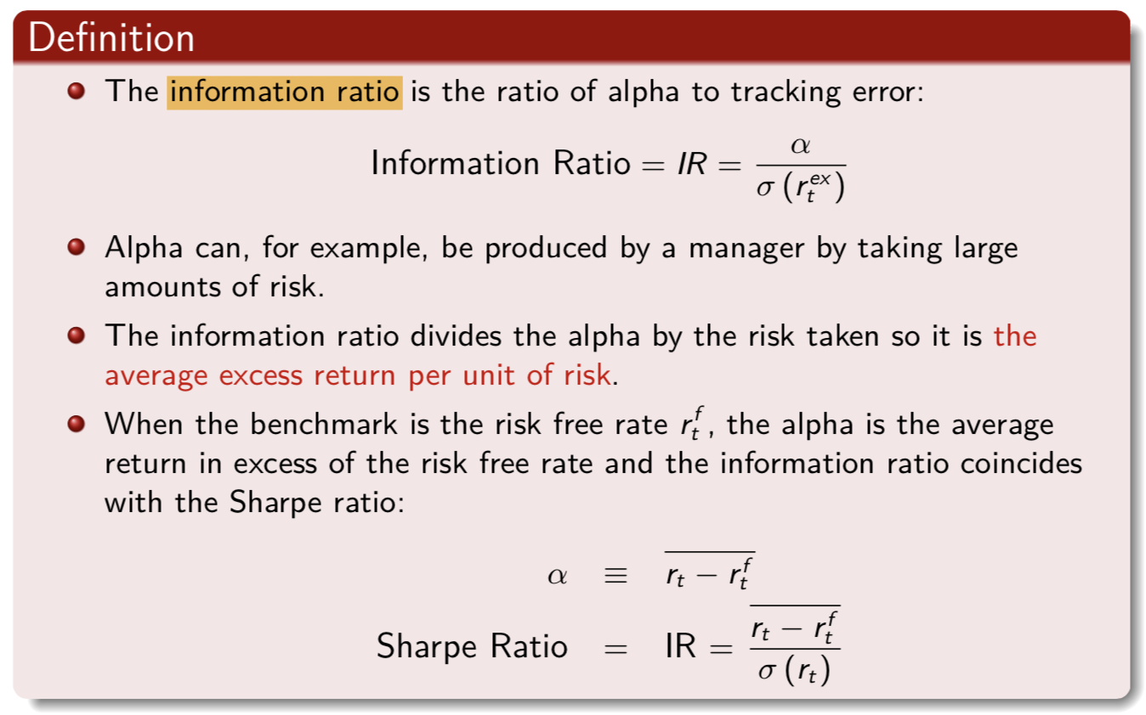

🡪 disadvantage of sharpe ratio:

Doesn’t make sense to compare an asset to risk-free asset

**[Benchmark]**

The concept of alpha requires first defining a benchmark against which alpha can be measured.

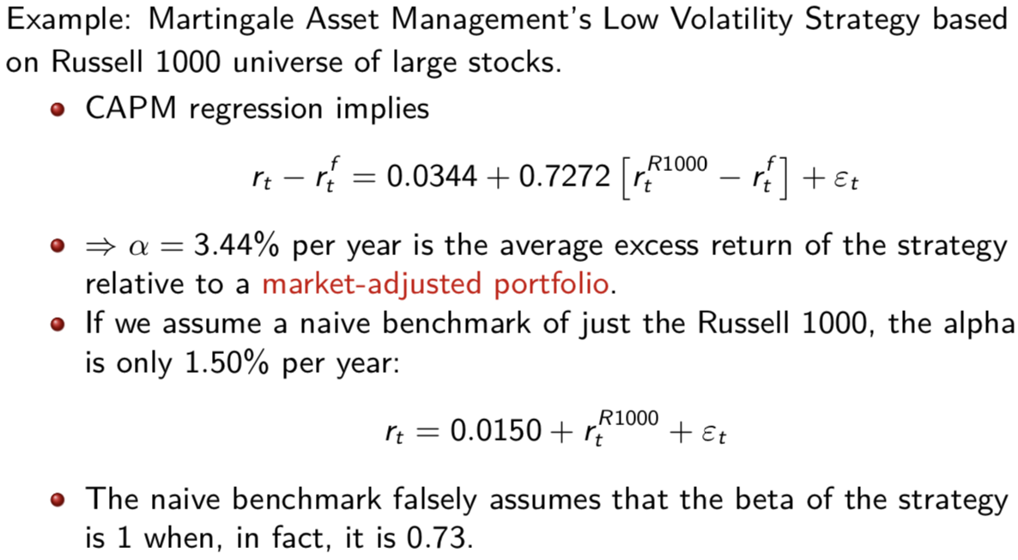

Ideal Benchmark

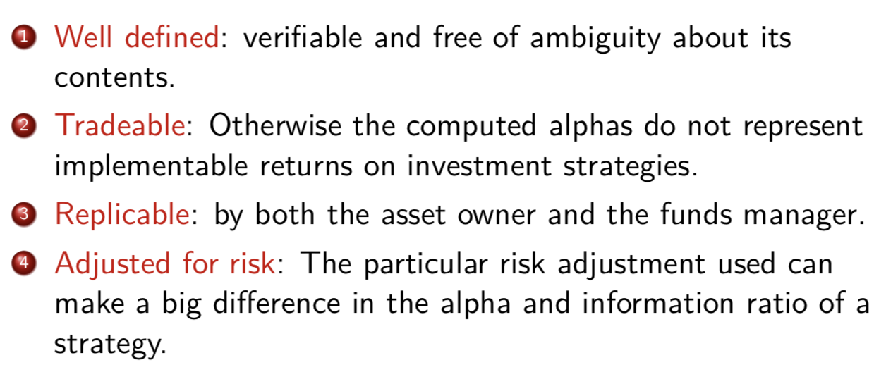

3. Active Management： Stock Market Prediction

Academic research has provided compelling theoretical and empirical evidence that the return on the aggregate stock market is predictable (e.g. Fama and French (1988, 1989), Campbell and Shiller (1988), Cochrane (2008), ...)

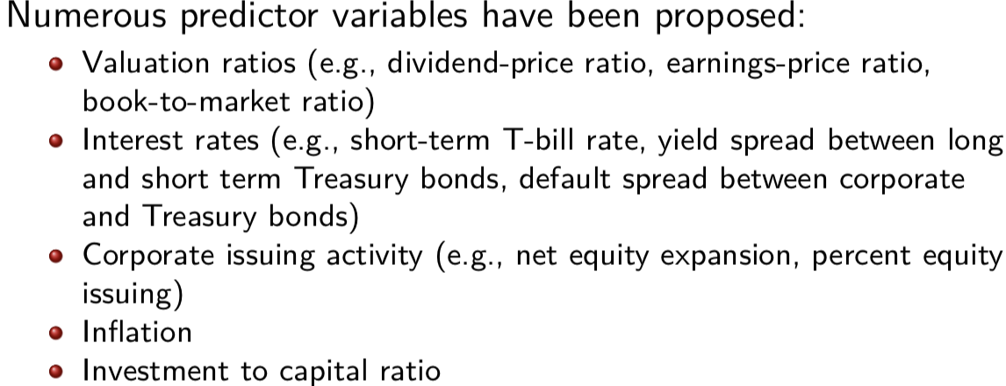

more issued equity in good times 🡪 less return

low in bad times 🡪 high return in stock market

high in bad times🡪 high return

in stock market

return of risky bond(BBA)- return of less risky bond(AAA)

All are [fundamental-market]: high🡪underpriced

In-sample regression

Run regression using entire sample

Emphasize *Out-Of-Sample (OOS)* performance as indicative of whether an investor can profitably time the market (OOS forecast uses only data available up to the time at which the forecast is made)

Commonly used OOS statistic:

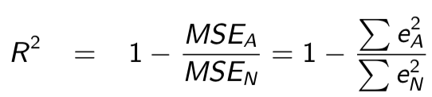

where eN and eA denote the vector of rolling OOS forecast errors from the historical mean model and the OLS model, respectively.

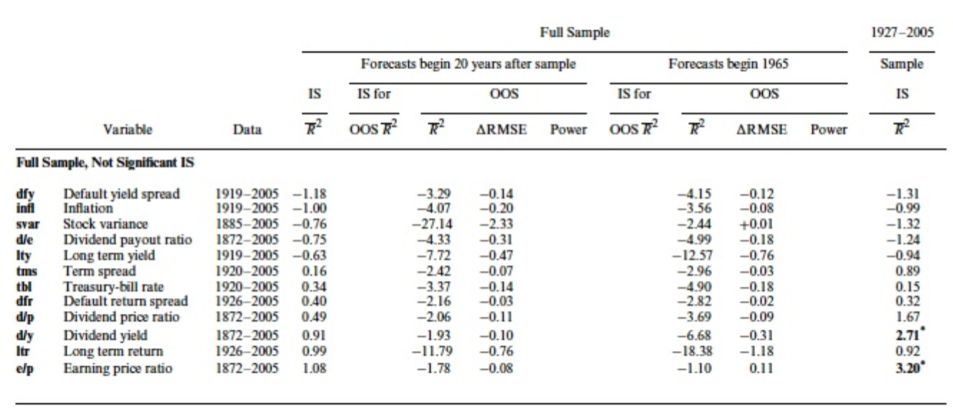

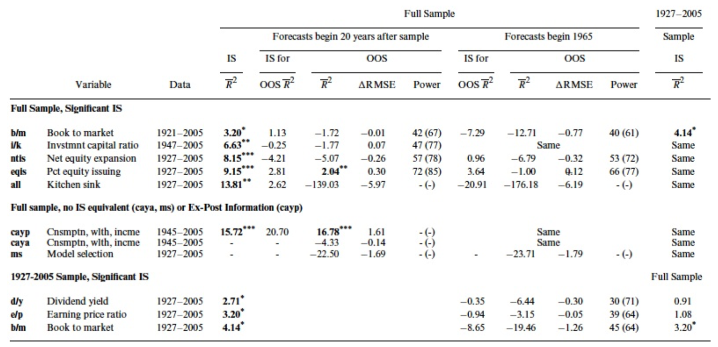

Plot the cumulative squared prediction errors of the prevailing mean minus the cumulative squared prediction errors of the predictive variable from the linear historical regression.

* Whenever the line increases, the ALTERNATIVE (predictor variable) predicted better.
* Whenever the line decreases, the NULL predicted better.

Note: The units of the graph are not intuitive, but the time series pattern allows diagnosis of years with good or bad performance.

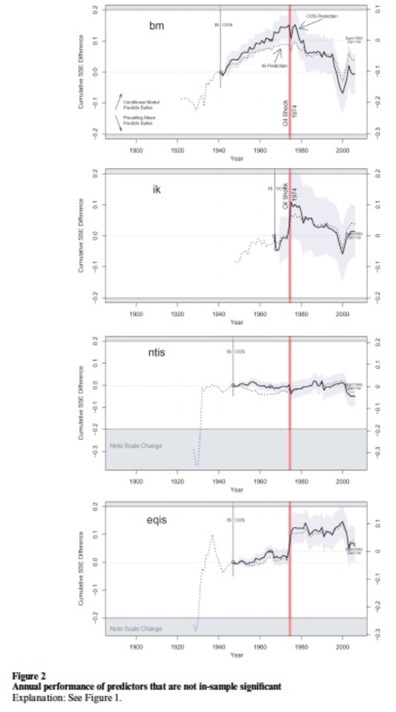 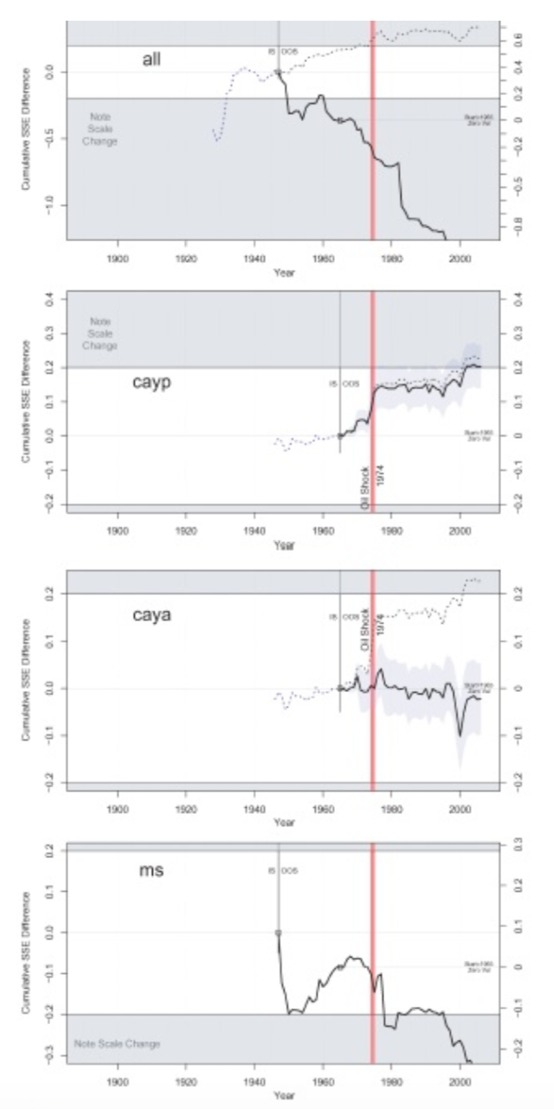

Rolling OOS regressions are typically estimated over short sample periods, and can easily generate perverse results (e.g., a negative coefficient when theory suggests it should be positive).

Explore the impact of imposing sensible restrictions on the OOS forecasting exercise:

1. Set the regression coefficient to zero whenever it has the ’wrong’ sign (different from the theoretically expected sign estimated over the full sample).

2. Assume investors rule out a negative equity premium, and set forecast to zero whenever it is negative.

3. Impose first the sign restriction on the coefficient, and then the sign restriction on the forecast.

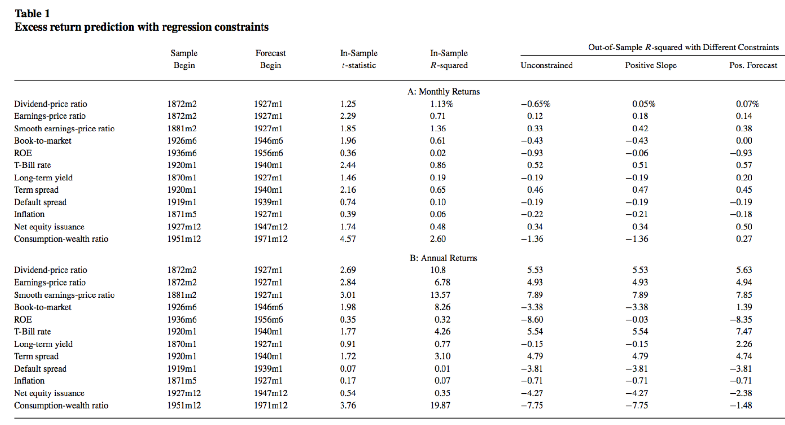

The restrictions never worsen and almost always improve the performance of the OOS regressions. However, the R2 statistics are small in magnitude raising the question of whether they are economically meaningful.

[How Large an R2 Should We Expect? ]

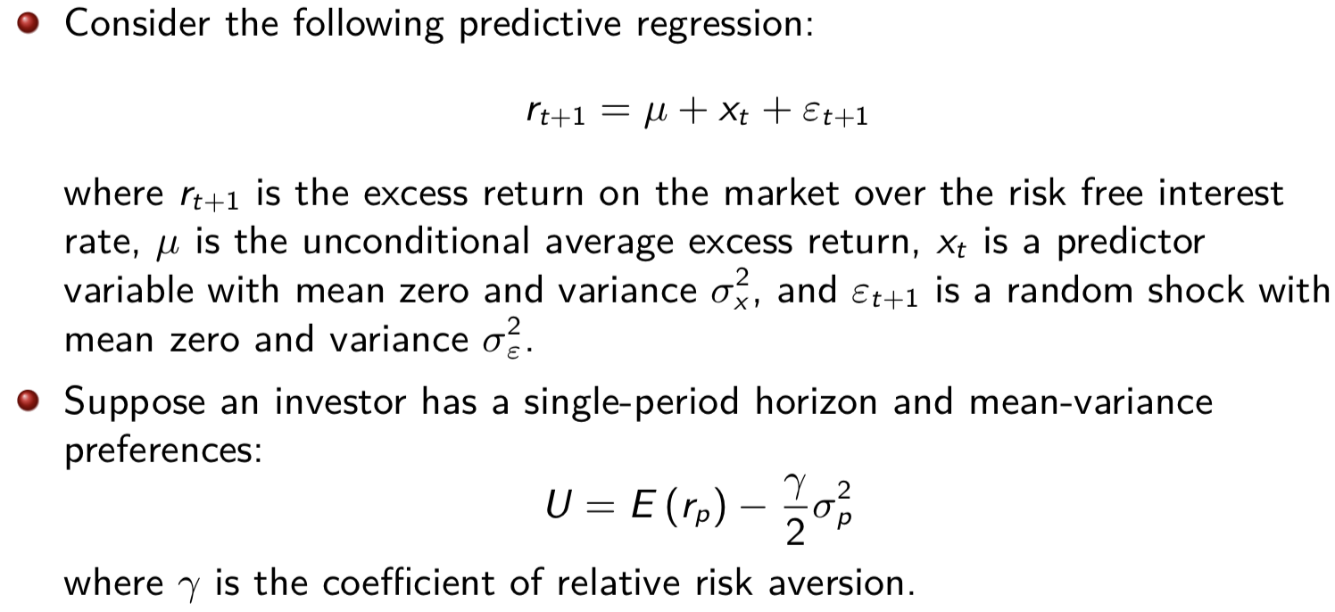

rm,t+1 – rf,t+1

(risk-free rate known)

Case 1: Passive - The investor doesn’t observe x

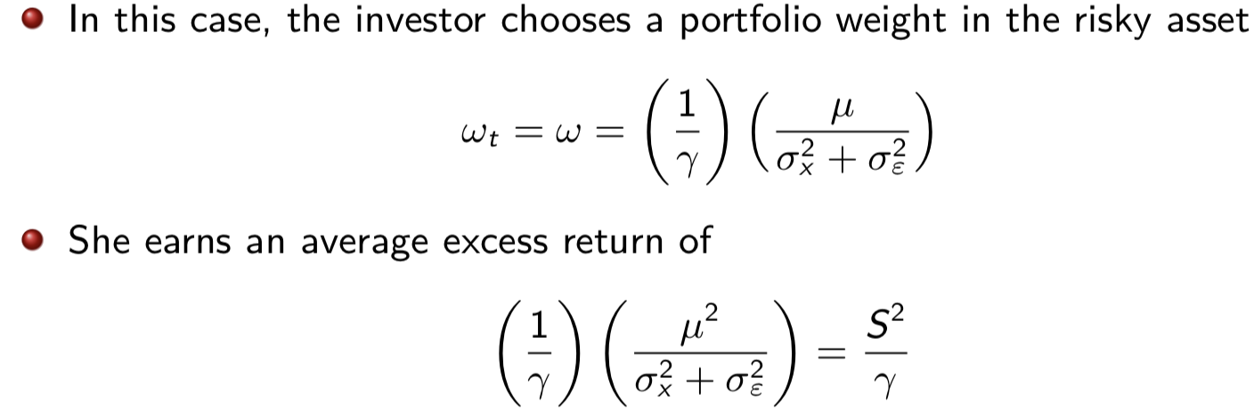

Case 2: Active - The investor observes x

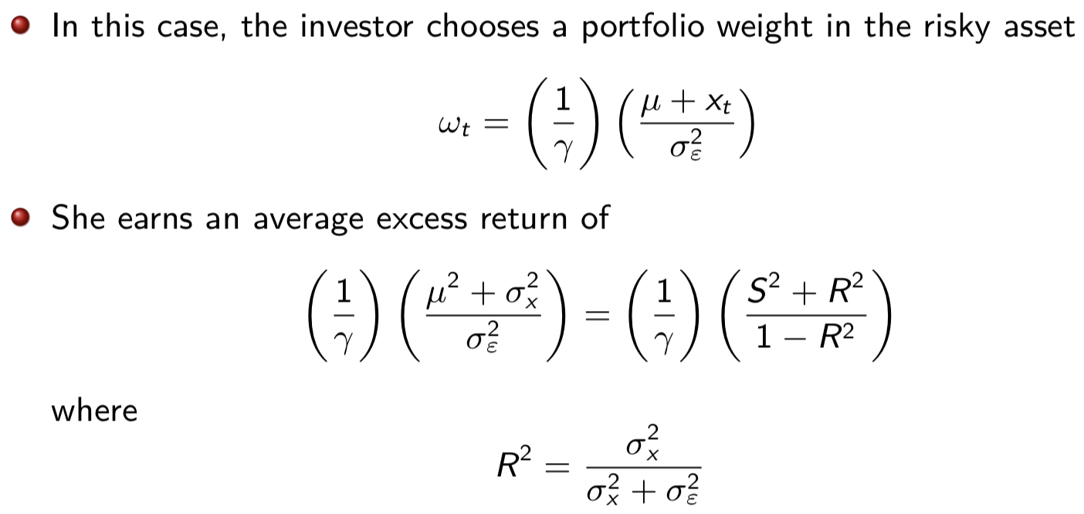

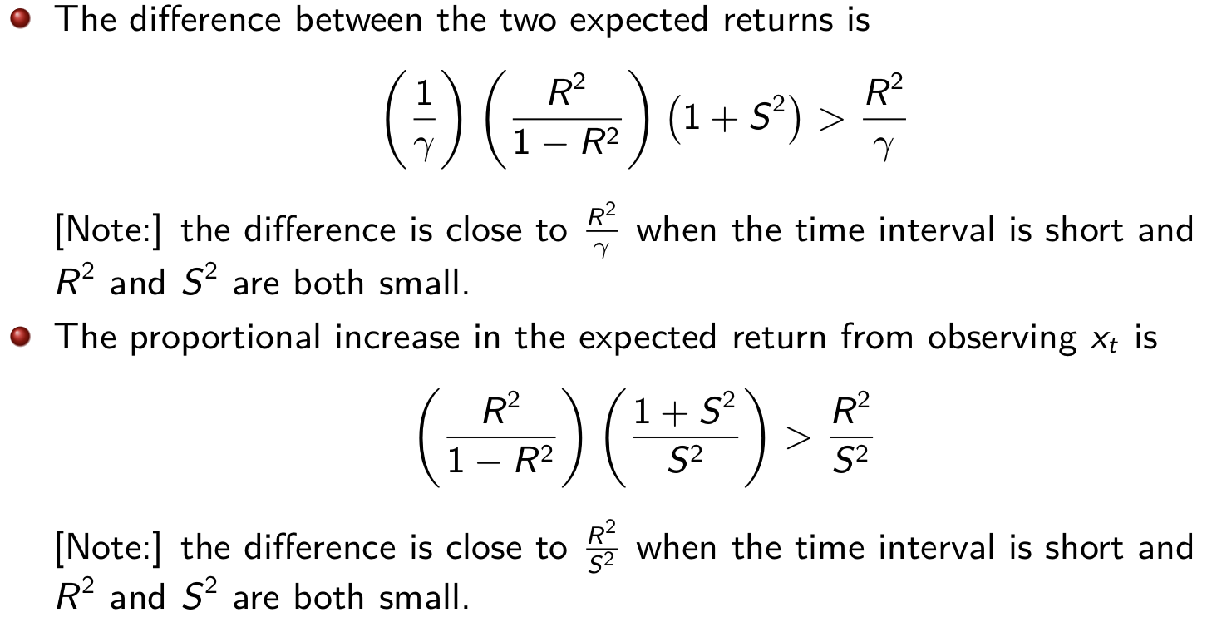

⇒ The correct way to judge the magnitude of R2 is to compare it with S2

If R2 is large relative to S2, the investor can use the information in the predictive regression to obtain a large proportional increase in expected return.

The absolute increase in portfolio return depends on risk aversion.

[Example]

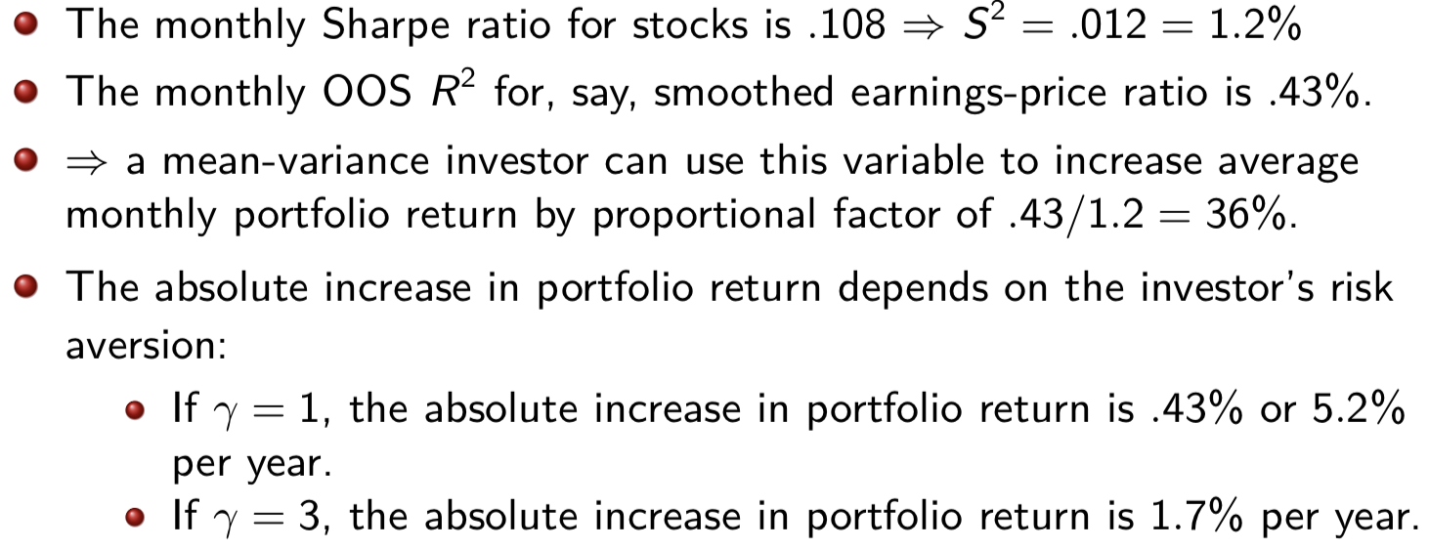

The investor who observes xt earns a higher portfolio return in part by taking on greater risk.

⇒ the increase in average return is not a pure welfare gain for a risk-averse investor.

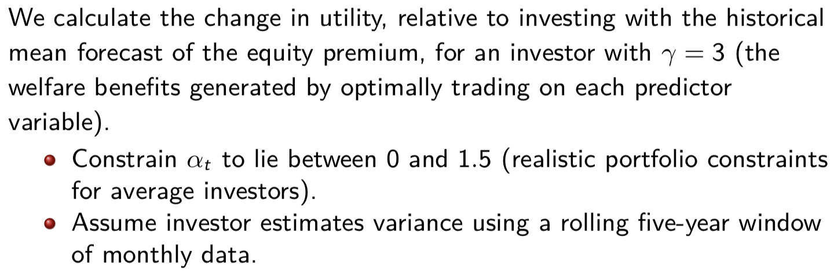

omega

Utility differences have units of expected annualized returns ⇒ they can be interpreted as transactions costs or management fees that investors would be willing to pay each year to exploit the information in the predictor variable.

4. Risk Factors in Equity Markets

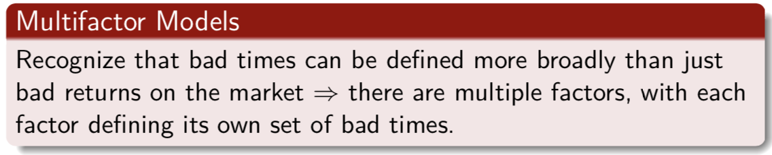

The first multifactor model was the **arbitrage pricing theory (APT)**, developed by Ross (1976).

The factors cannot be arbitraged or diversified away (hence the word ‘arbitrage’).

⇒ in equilibrium, investors must be compensated for bearing these multiple sources of factor risk.

The APT is silent on the number and identity of the factors.

**[Example: Fama-French (FF) 3-Factor Model]**

* Size effect: Stocks with lower market capitalization (small stocks) tend to have higher average returns than large stocks, after adjusting for their betas
* Value effect: Value stocks (stocks with high ratios of a fundamental e.g., book value, sales, earnings, dividends, to price) tend to have higher average returns than growth stocks (stocks with low ratios of fundamentals to price)

Fama and French (1993): propose a three-factor model to capture the patterns in U.S. average returns associated with size and value versus growth:



rSMB,t is a factor mimicking portfolio constructed to capture the size premium.

rHML,t is a factor mimicking portfolio constructed to capture the value premium.

**Construction of Factors**

* The NYSE, AMEX, and NASDAQ stocks are divided into 2 size (market-equity) groups, Small and Big, based on the median of the ranked values of market equity for NYSE stocks.
* The NYSE, AMEX, and NASDAQ stocks are divided into 3 book-to-market-equity groups based on the breakpoints for the bottom 30% (Low), middle 40% (Medium), and top 30% (High) of the ranked values of BE/ME for NYSE stocks.

BE/ME is the book common equity for the fiscal year ending in calender year t − 1, divided by market equity at the end of December of t − 1.

The decision to sort firms into 3 groups on BE/ME and only 2 on ME is based on the evidence that the former plays a stronger role in average stock returns than size.

* 6 portfolios (S/L, S/M, S/H, B/L, B/M, B/H) are constructed from the intersection of the two ME and 3 BE/ME groups.
* Monthly value-weighted returns on the 6 portfolios are calculated from July of year t to June of year t + 1.
* The portfolios are **reformed** in June of t + 1. (Repeat the process)

[The more you rebalance, the more transaction costs 🡪 Benefits decreases.]

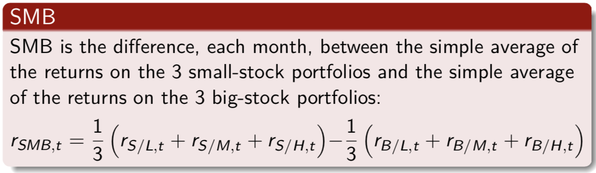

SMB is the difference between the returns on small and big-stock portfolios with about the same weighted-average book-to-market equity. ⇒it is largely free of the influence of BE/ME, focusing instead on the different return behaviors of small and big stocks.

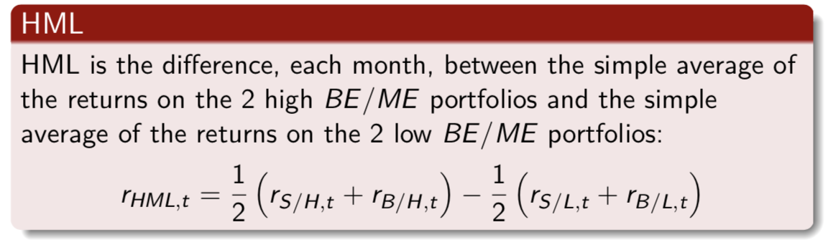

The two components of HML have about the same weighted-average size. ⇒it is largely free of the size factor in returns, focusing instead on the different return behaviors of high and low BE/ME firms.

The correlation between monthly rSMB,t and rHML,t factors is −0.08.

Excess returns on 25 portfolios formed on size and book-to-market equity (to determine whether the factor mimicking portfolios SMB and HML capture common risk factors in stock returns related to size and BE/ME).

The 25 portfolios also produce a wide spread of average returns to be explained by competing asset-pricing models. The 25 size-BE/ME portfolios are formed from the intersection of 5 ME-sorted portfolios and 5 BE/ME-sorted portfolios.

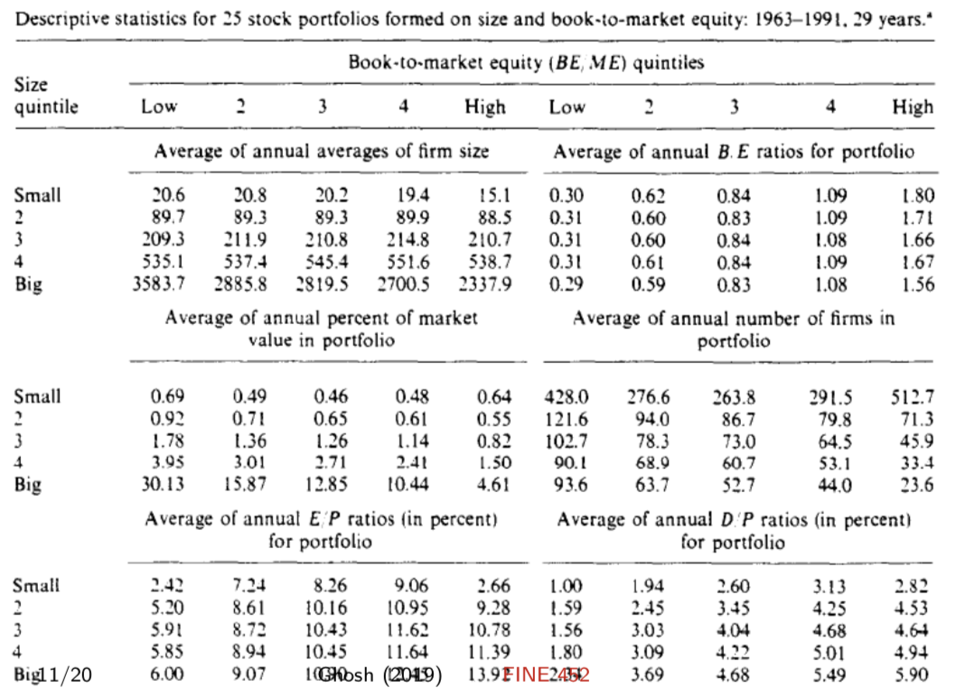

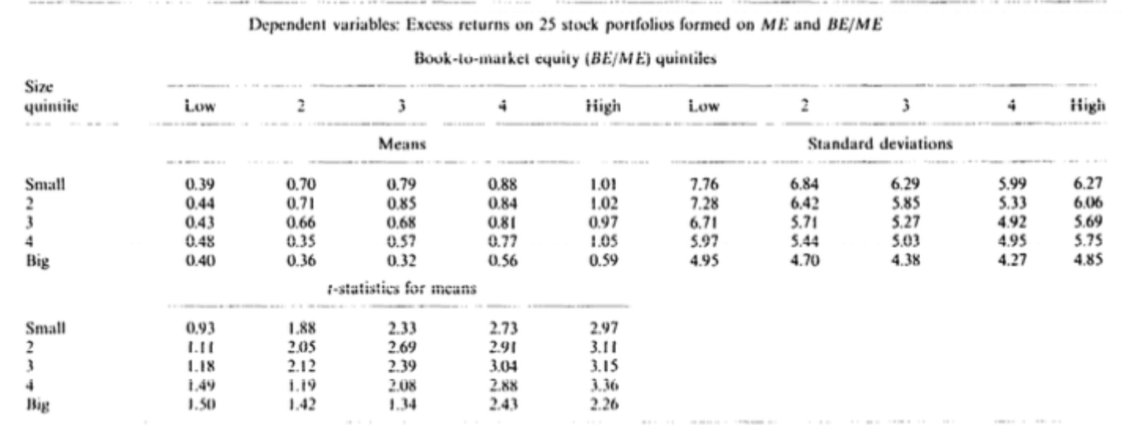

[Summary]

* Produce a wide range of average excess returns to be explained (.32% to 1.05% per month).
* Confirm negative relation between size and average return.
* Confirm stronger positive relation between average return and book-to-market equity.

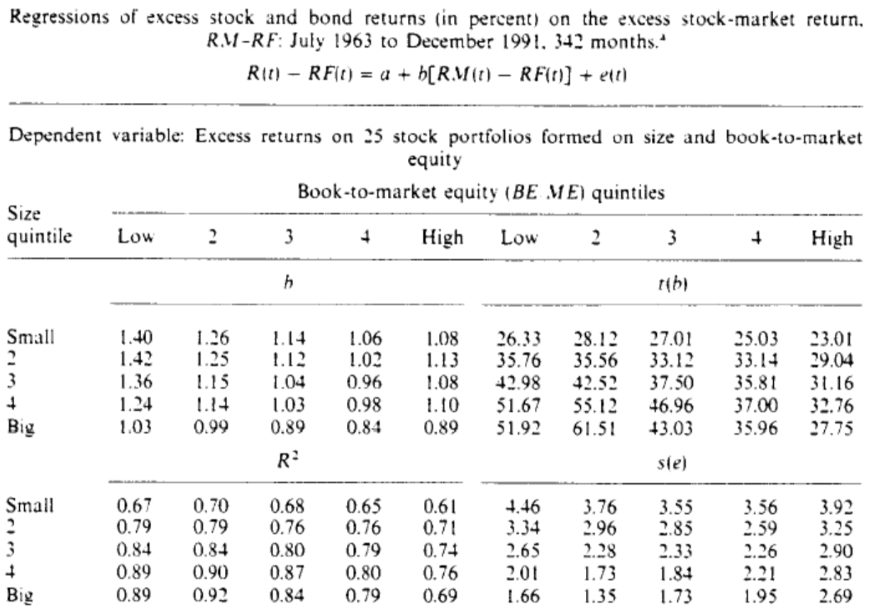

The market factor leaves much of the variation in stock returns unexplained (particularly for small-stock and high-BE/ME portfolios).

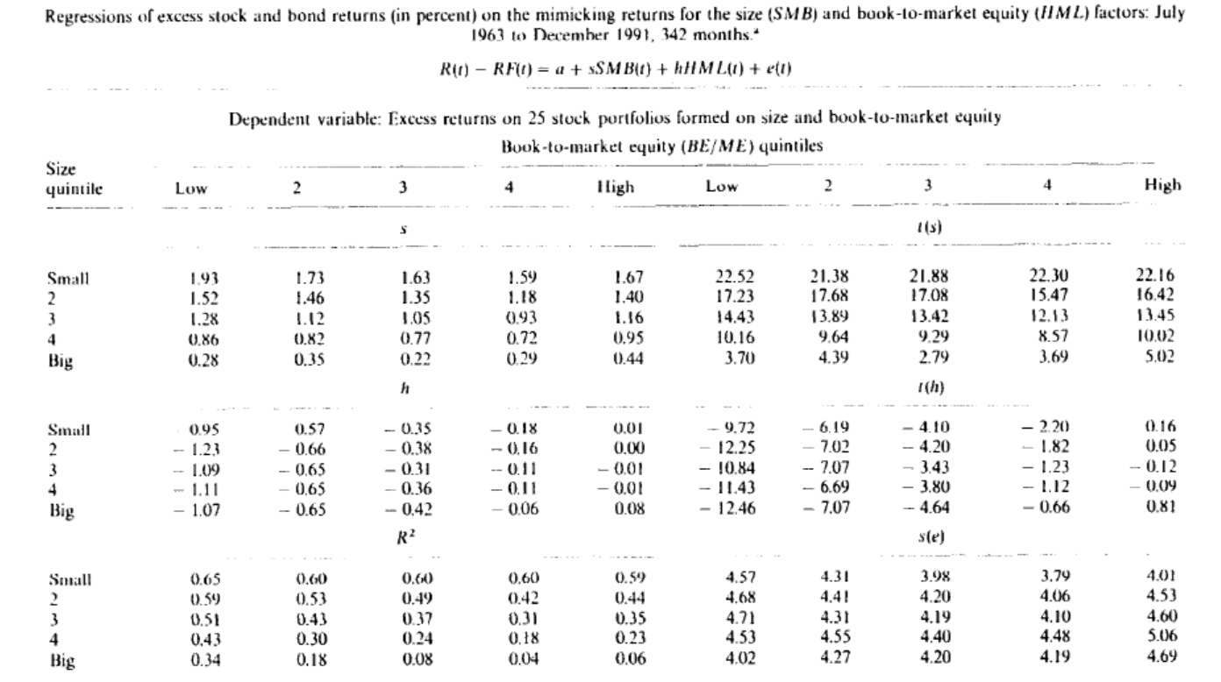

In the absence of competition from the market factor, SMB and HML typically capture substantial time variation in stock returns.

However, they leave common variation in stock returns that is picked up by the market (especially for large-size portfolios)

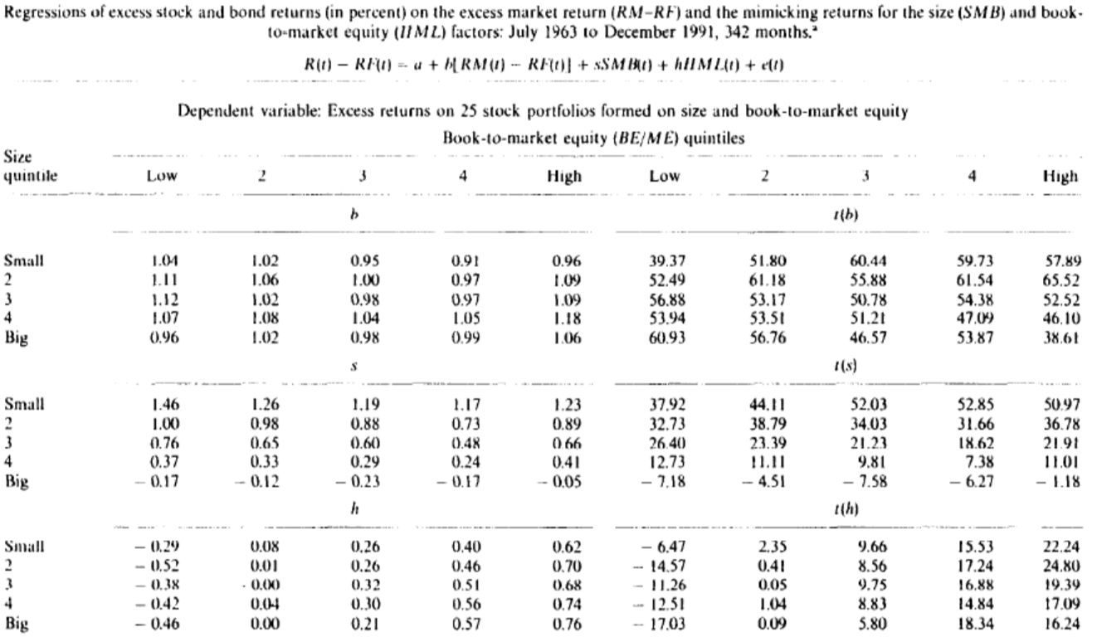

SMB captures shared variation in returns missed by the market and HML.

HML captures shared variation in returns missed by the market and SMB.

Addition of SMB and HML causes the market βs to collapse toward 1.

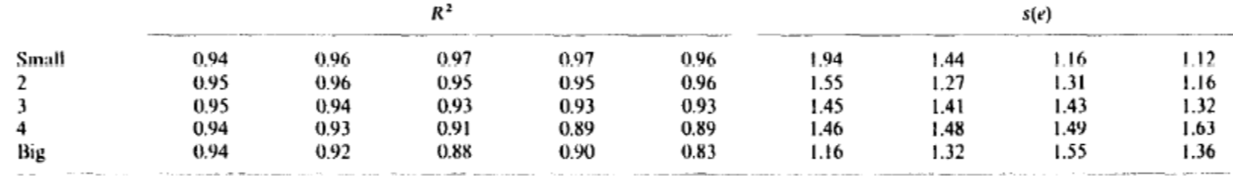

Addition of SMB and HML causes large increases in R2.

Cross-Section of Average Returns

Average-return tests centre on the intercepts in the time-series regressions.

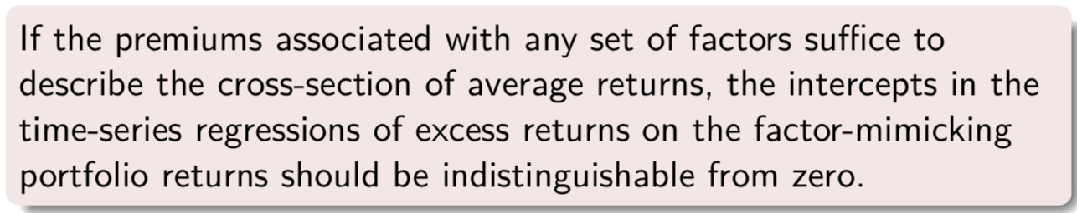

Intercepts from Time-Series Regressions

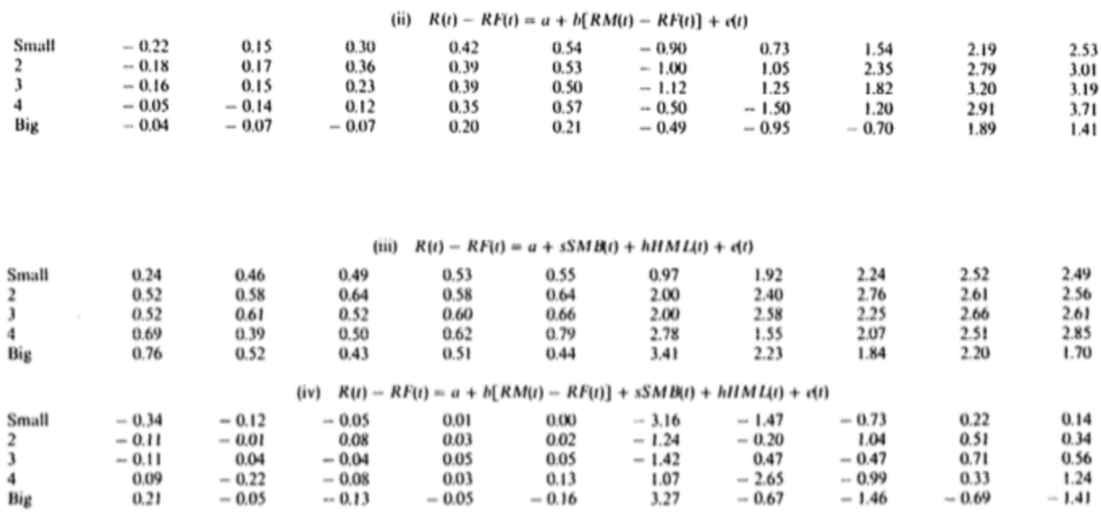

The 3 factors do a good job explaining the cross-section of stock returns.

**The size and book-to-market factors can explain the differences in average returns across stocks, but the market factor is needed to explain why stock returns are on average above the one-month bill rate.**